**PROGRAM [3]:**

global N

N = 4

def printSolution(board):

for i in range(N):

for j in range(N):

print (board[i][j],end=' ')

print()

def isSafe(board, row, col):

for i in range(col):

if board[row][i] == 1:

return False

for i, j in zip(range(row, -1, -1), range(col, -1, -1)):

if board[i][j] == 1:

return False

for i, j in zip(range(row, N, 1), range(col, -1, -1)):

if board[i][j] == 1:

return False

return True

def solveNQUtil(board, col):

if col >= N:

return True

for i in range(N):

if isSafe(board, i, col):

board[i][col] = 1

if solveNQUtil(board, col + 1) == True:

return True

**OUTPUT [3]:**

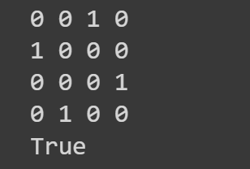

board[i][col] = 0

return False

def solveNQ():

board = [ [0, 0, 0, 0],

[0, 0, 0, 0],

[0, 0, 0, 0],

[0, 0, 0, 0]

]

if solveNQUtil(board, 0) == False:

print ("Solution does not exist")

return False

printSolution(board)

return True

solveNQ()